Chapter 19, Solution 88

To get 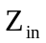, consider the network in Fig. (a).
R_{s}
+
−
(a)

I₁
I₂
+
V₁
−
V_{s}
R_{L}
+
V₂
−
Two-Port
Z_{in}
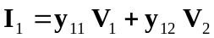 (1)
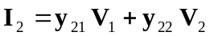 (2)

But 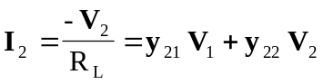
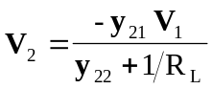 (3)

Substituting (3) into (1) yields
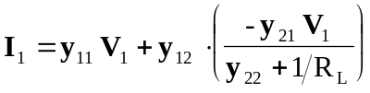, 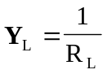
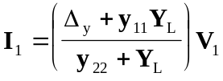, 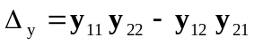

or 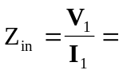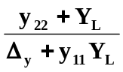

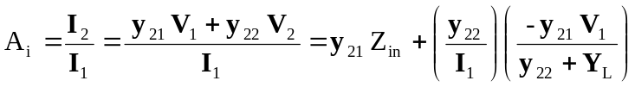
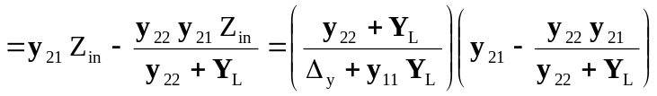

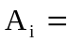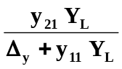

From (3),
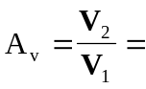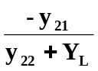

To get 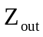, consider the circuit in Fig. (b).
+
−
(b)

I₁
I₂
+
V₁
−
R_{s}
V₂
Two-Port
Z_{out}

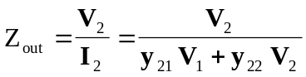 (4)

But 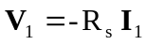

Substituting this into (1) yields
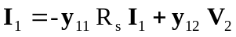
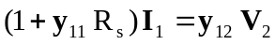
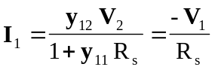
or 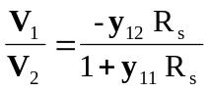

Substituting this into (4) gives
